

HTML PROFECT

Group members:

1.Leela Nandan Satya Syama Sundar (12209112)

2.Naveen (12212253)

3.Mukesh (12212283)

MOVIE TICKET BOOKING MANAGEMENT

## **DECLARATION: -**

## I hereby declare that this submission is our own work and that to the best of our knowledge and beliefs. It contains no material I previously published or written by neither any person nor material which to a substant extent has been accepted for the award of any other degree or diploma of the university or other institute of higher learning, except where due acknowledgment has been made in the text.

## Explanation: -

In this project, we have created 4 web pages and linked them to one by using HTML.

After logging into the account, you can see a Home Page with a search bar and nav bar that navigate you to the login page and to buttons named

Now playing and Book tickets.

This website will make users ease to Book tickets in the modern era. In this, we have divided our work into 3 parts:

1. Login page
2. Home page and slider
3. Booking page

## CODE: -

Contains code for log-in, homepage, seating page, and now playing with interior CSS and HTML

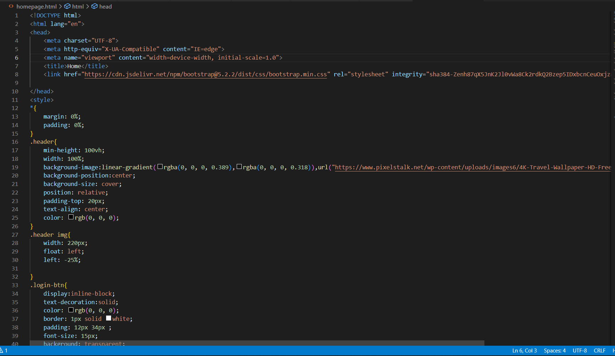

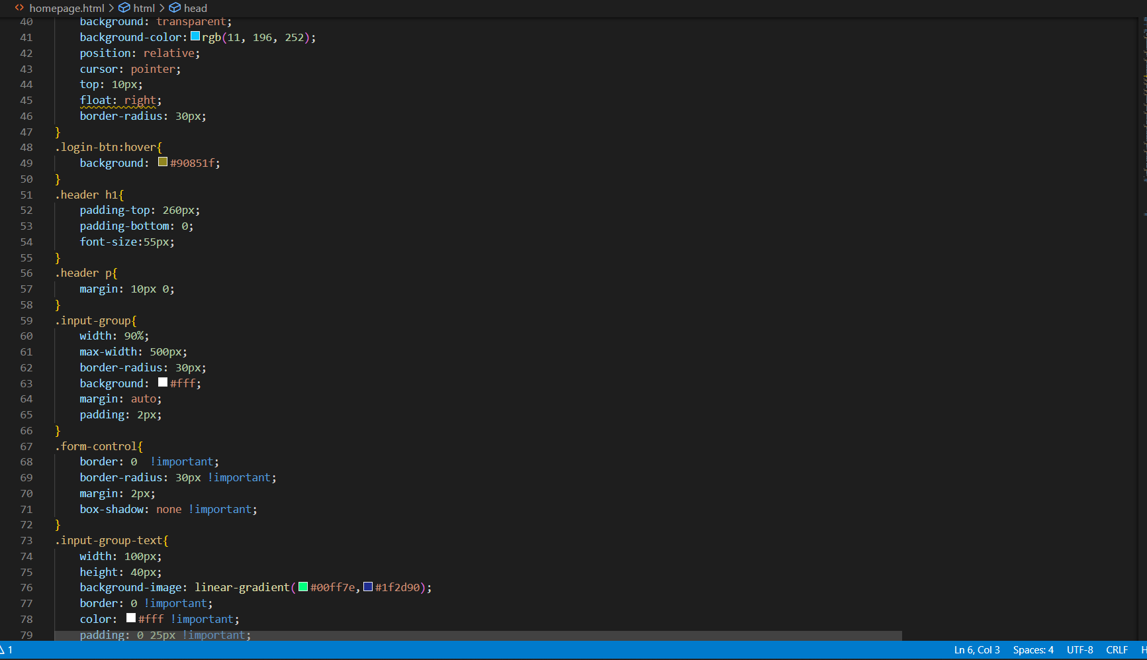

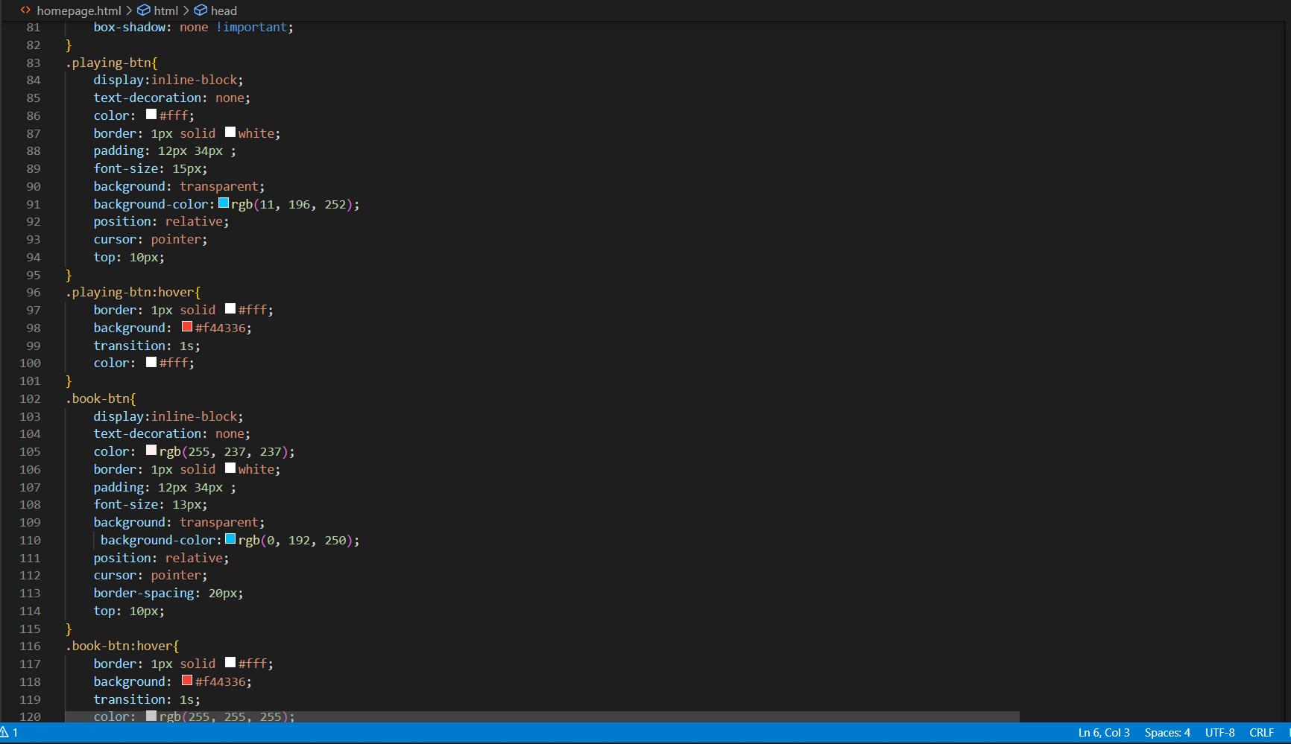

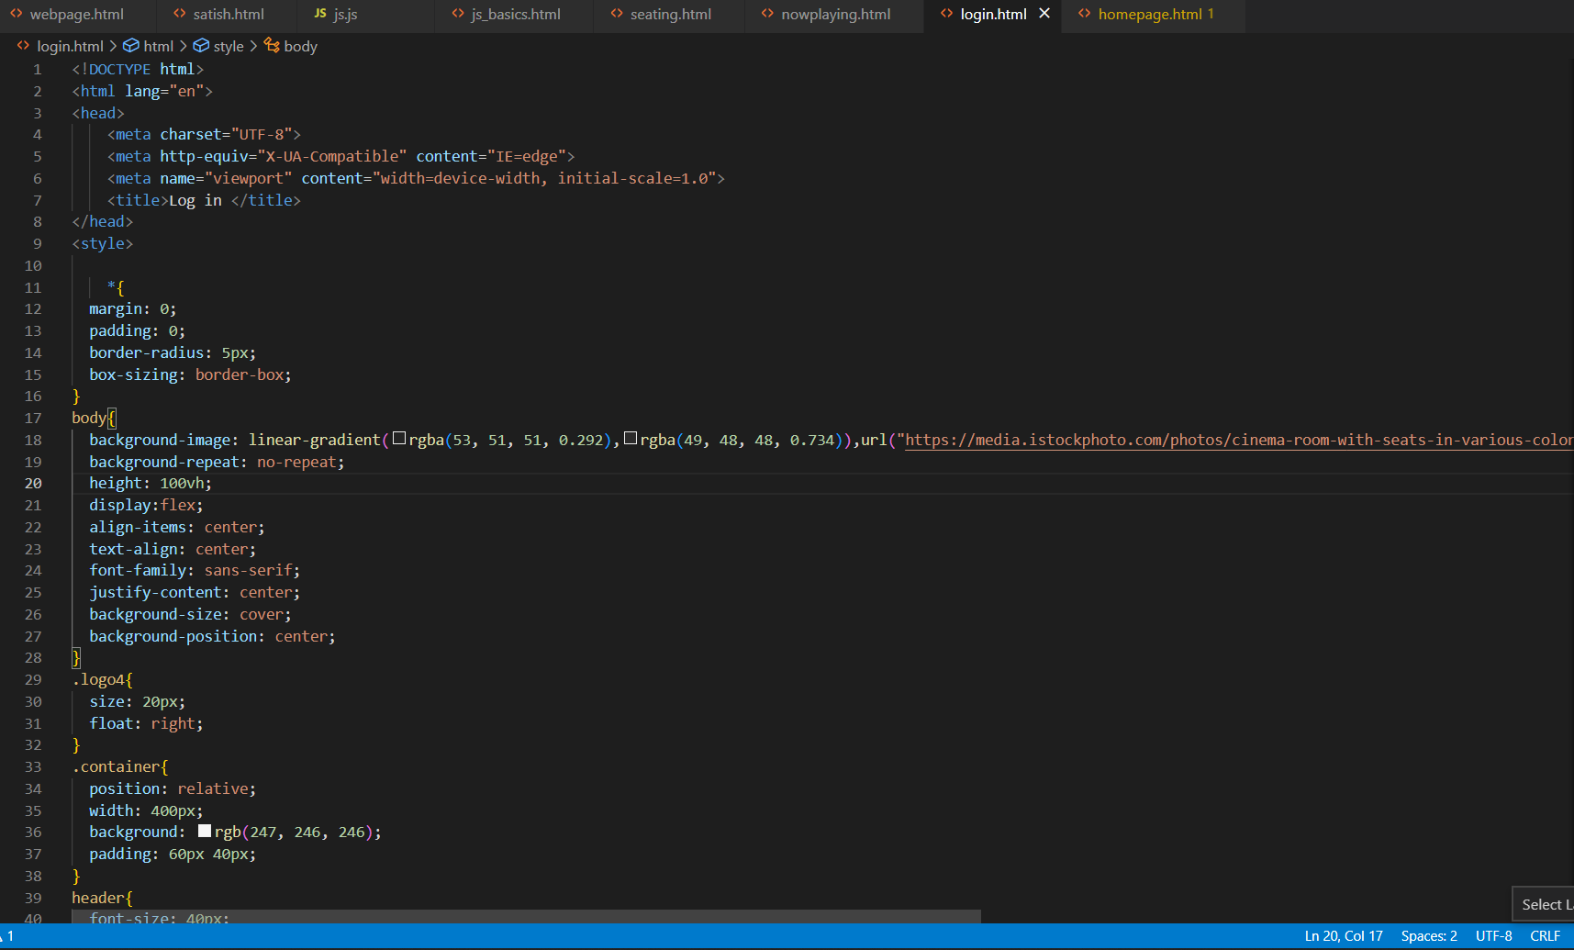

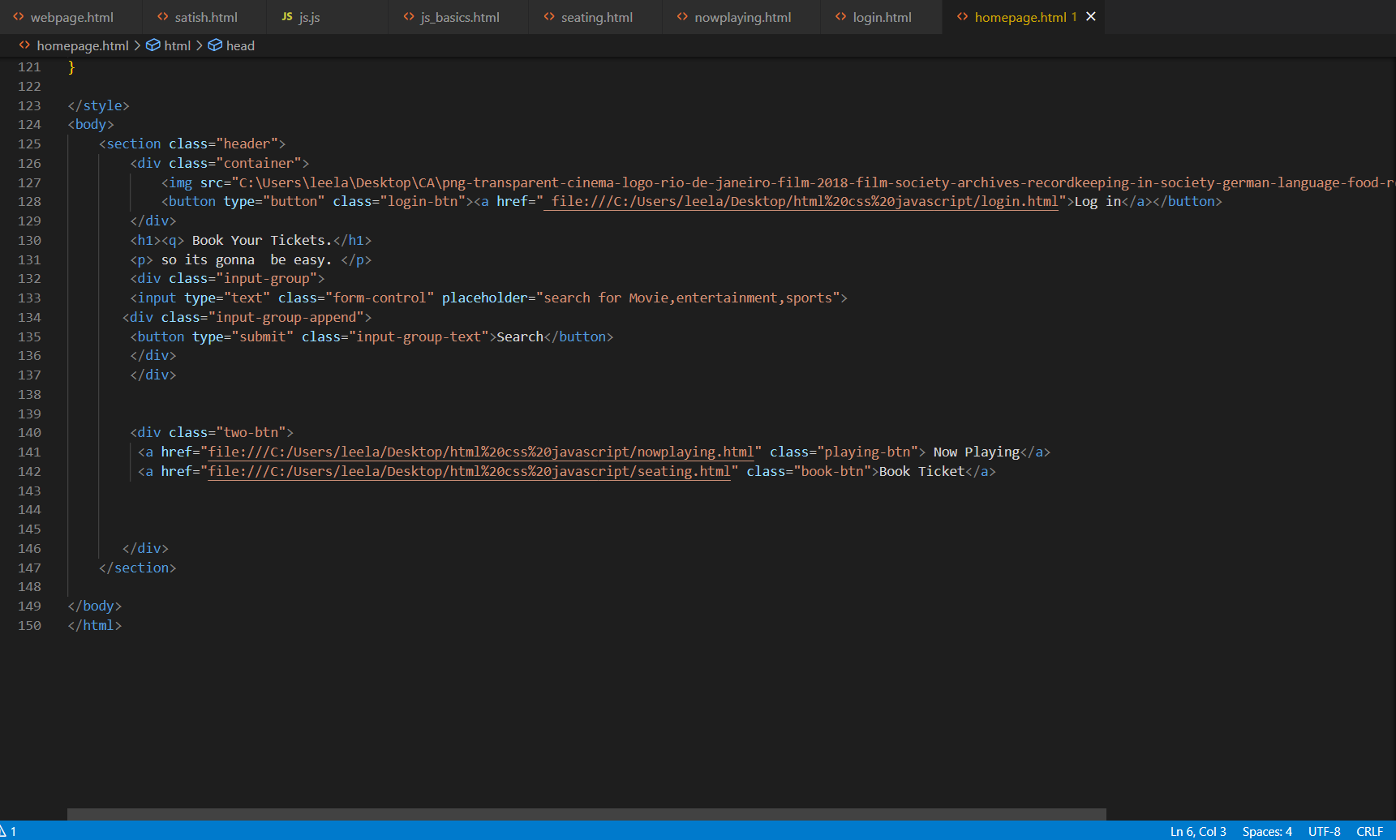

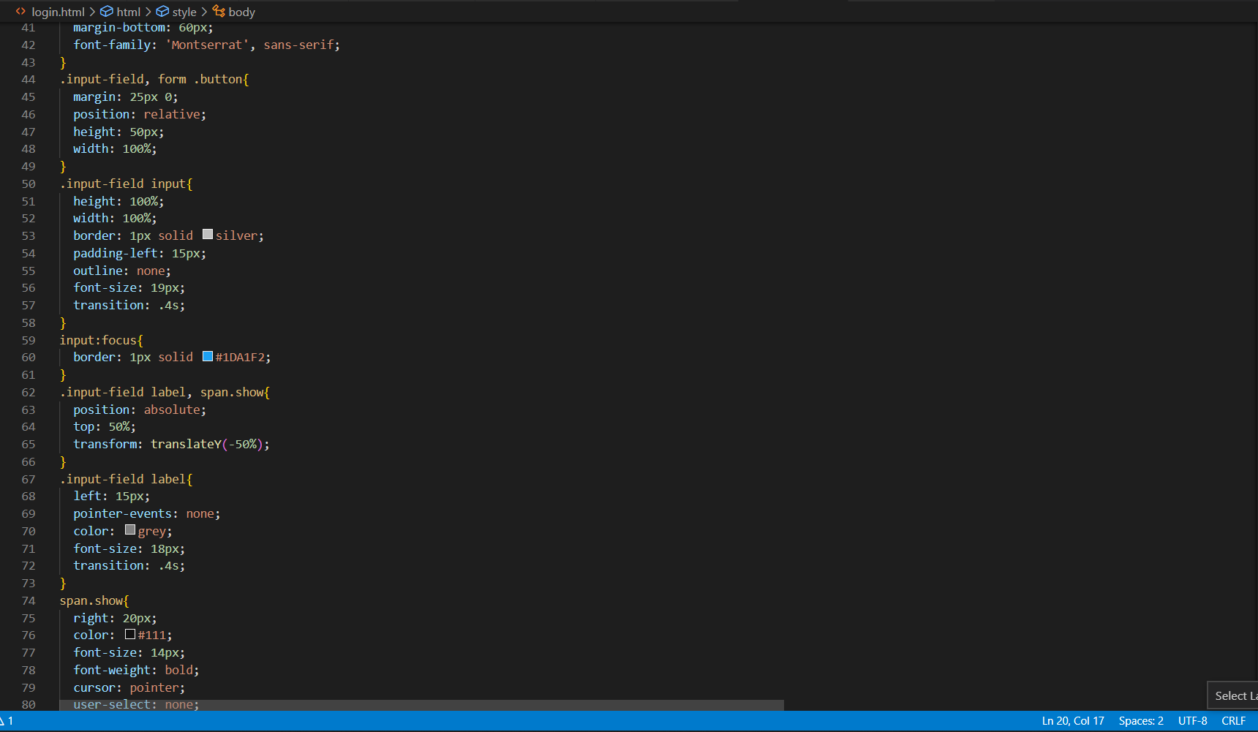

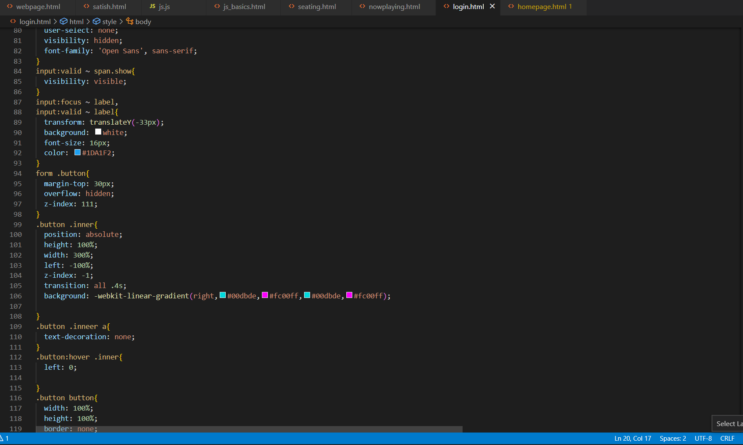

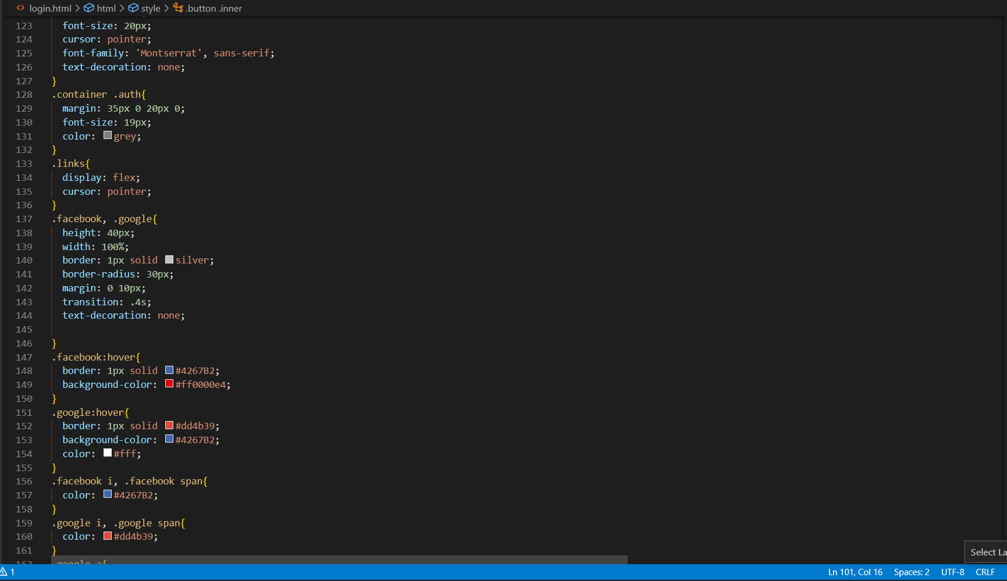

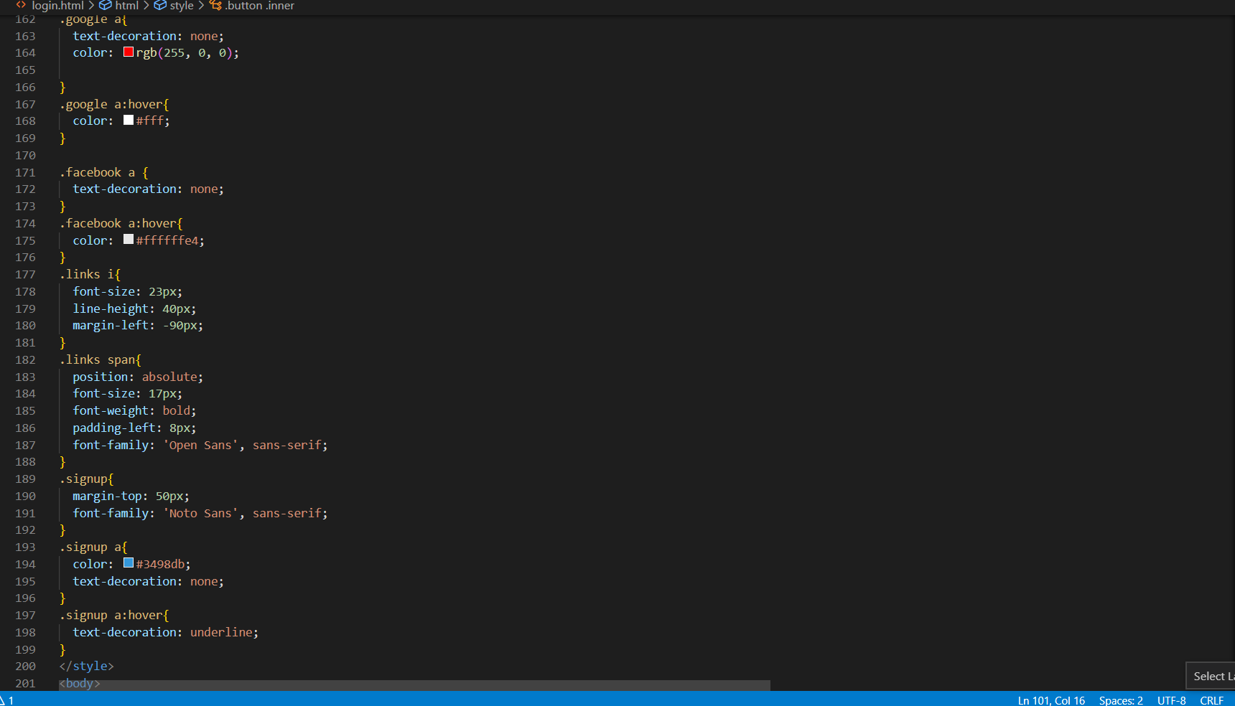

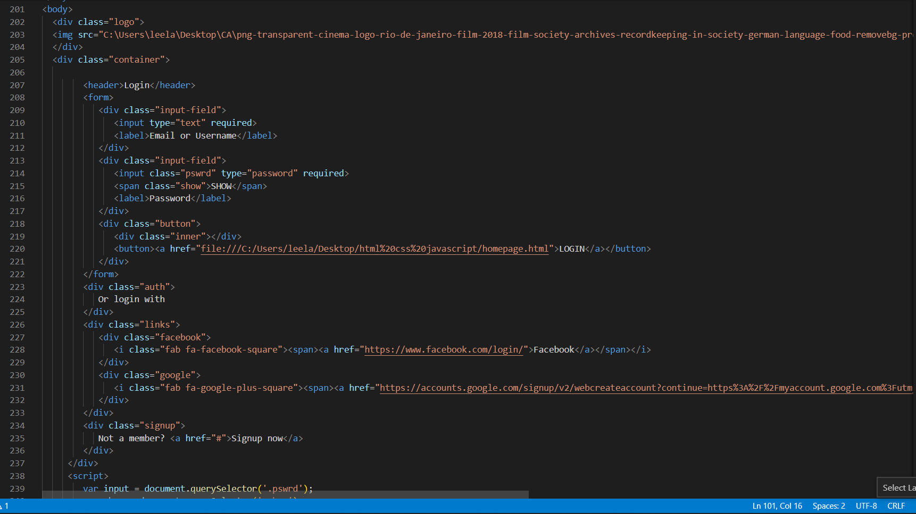

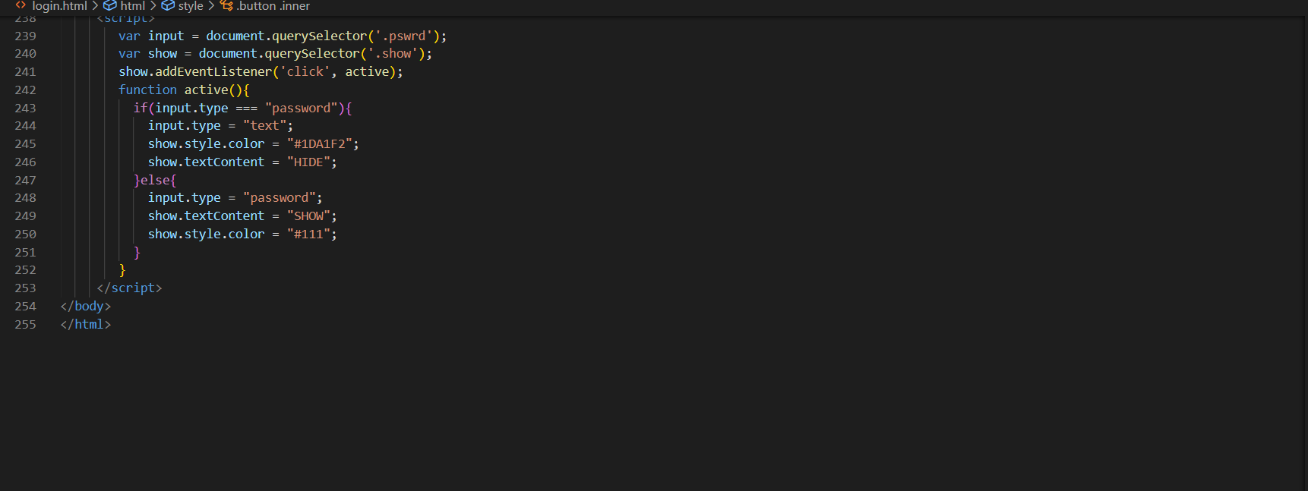

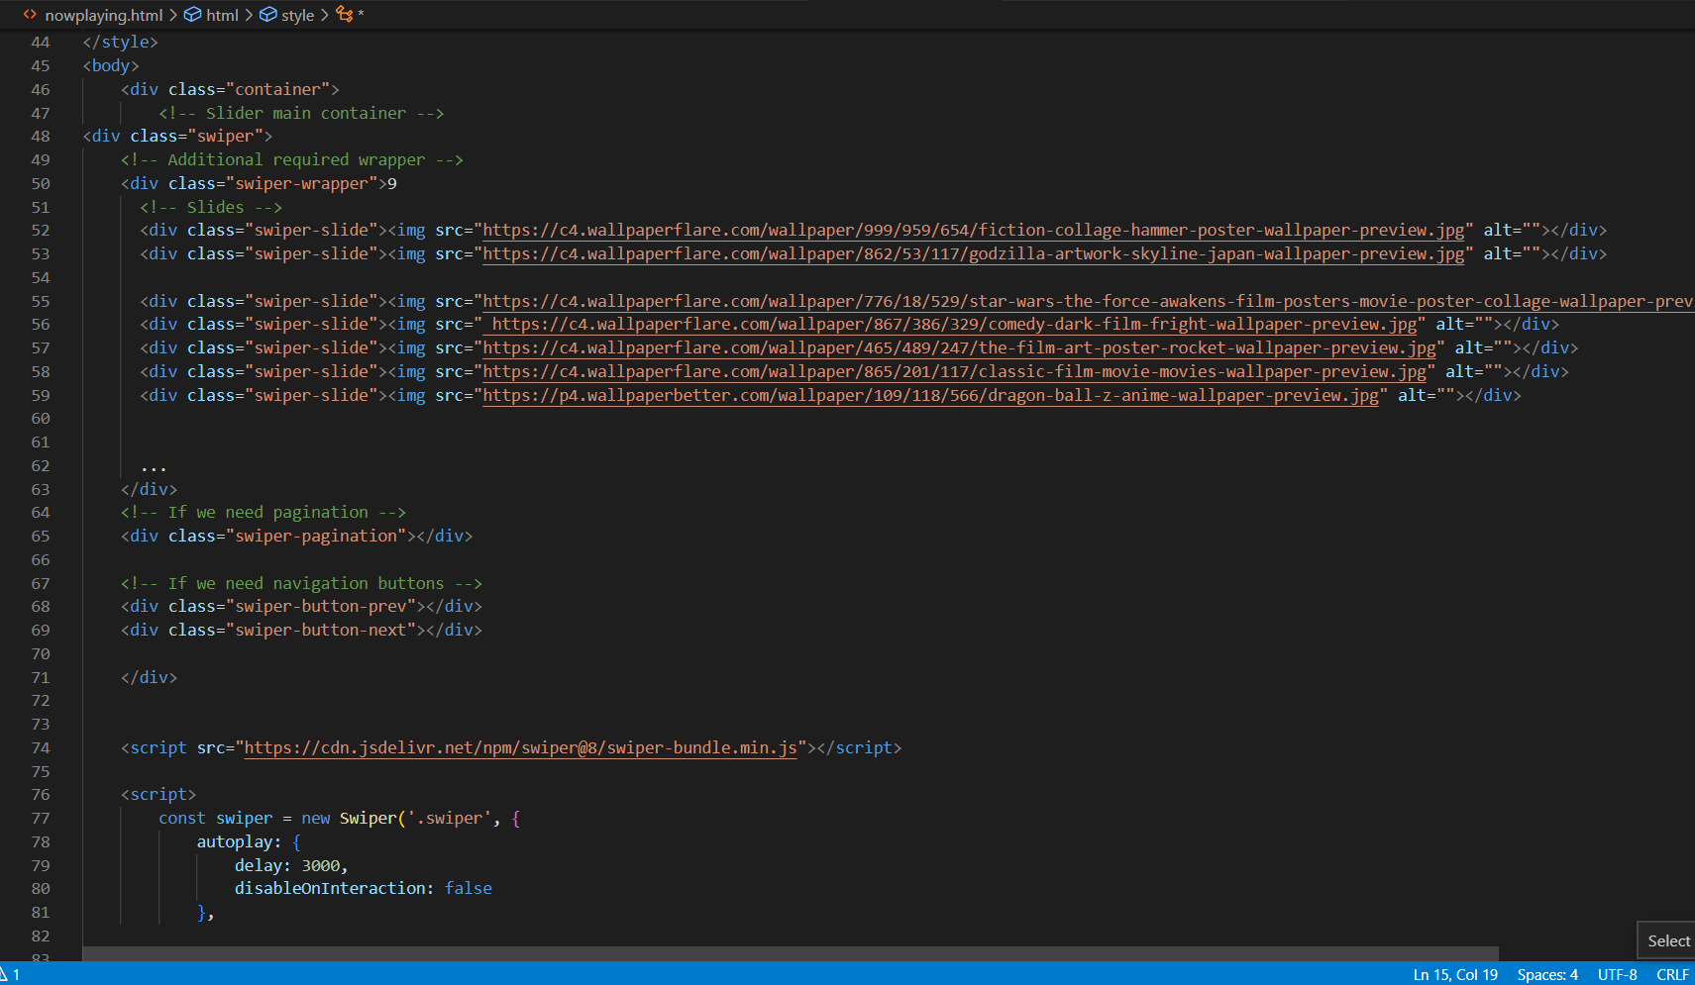

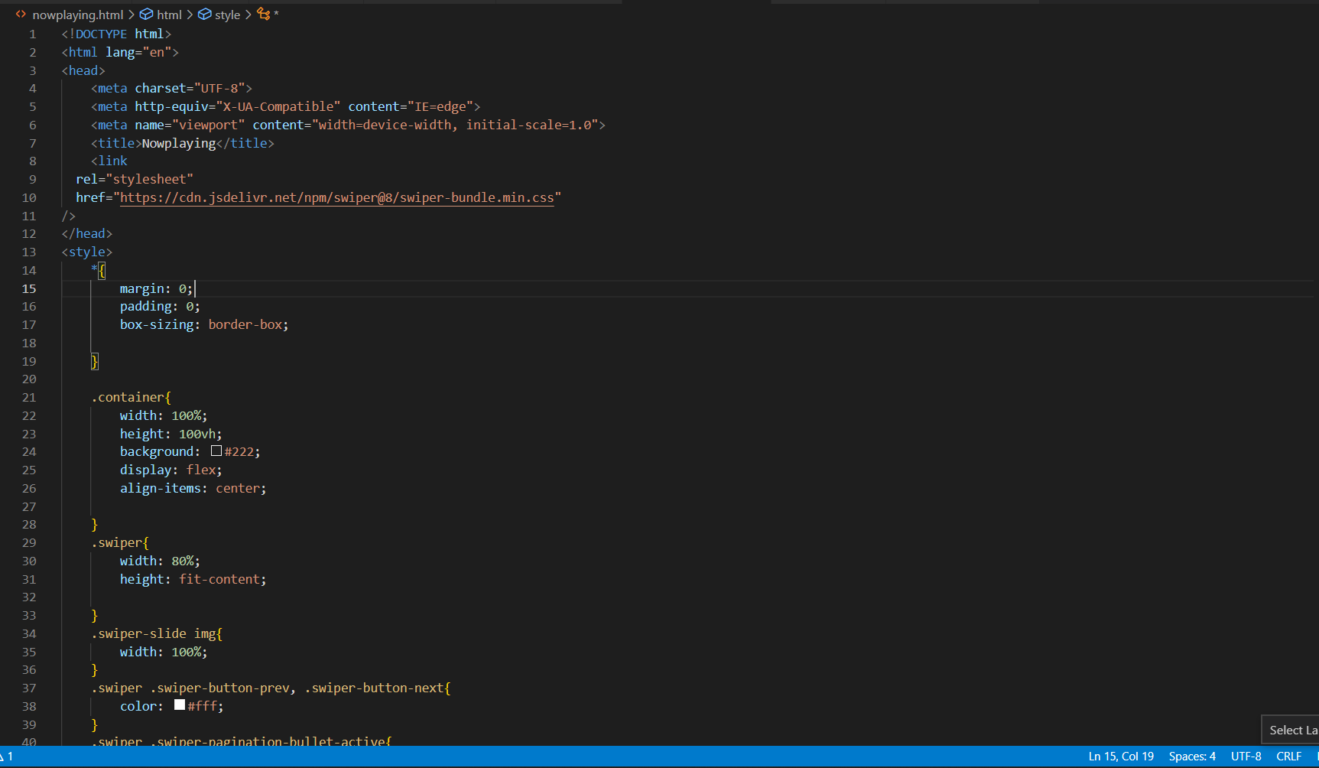

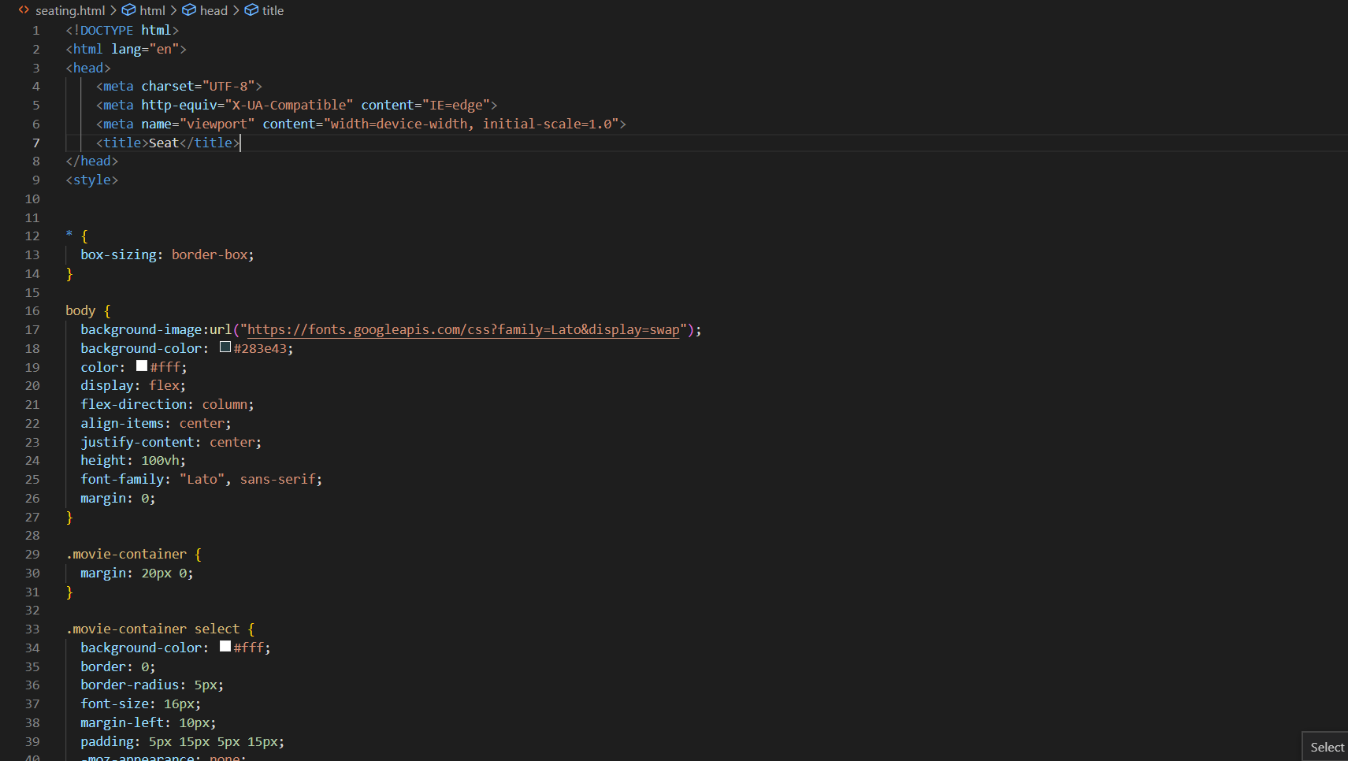

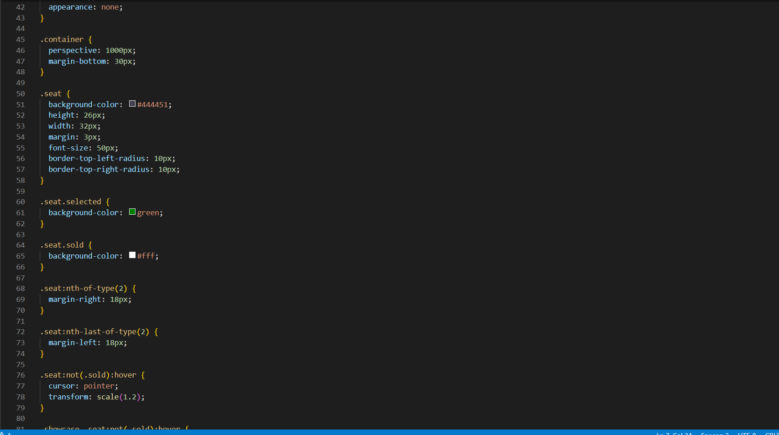

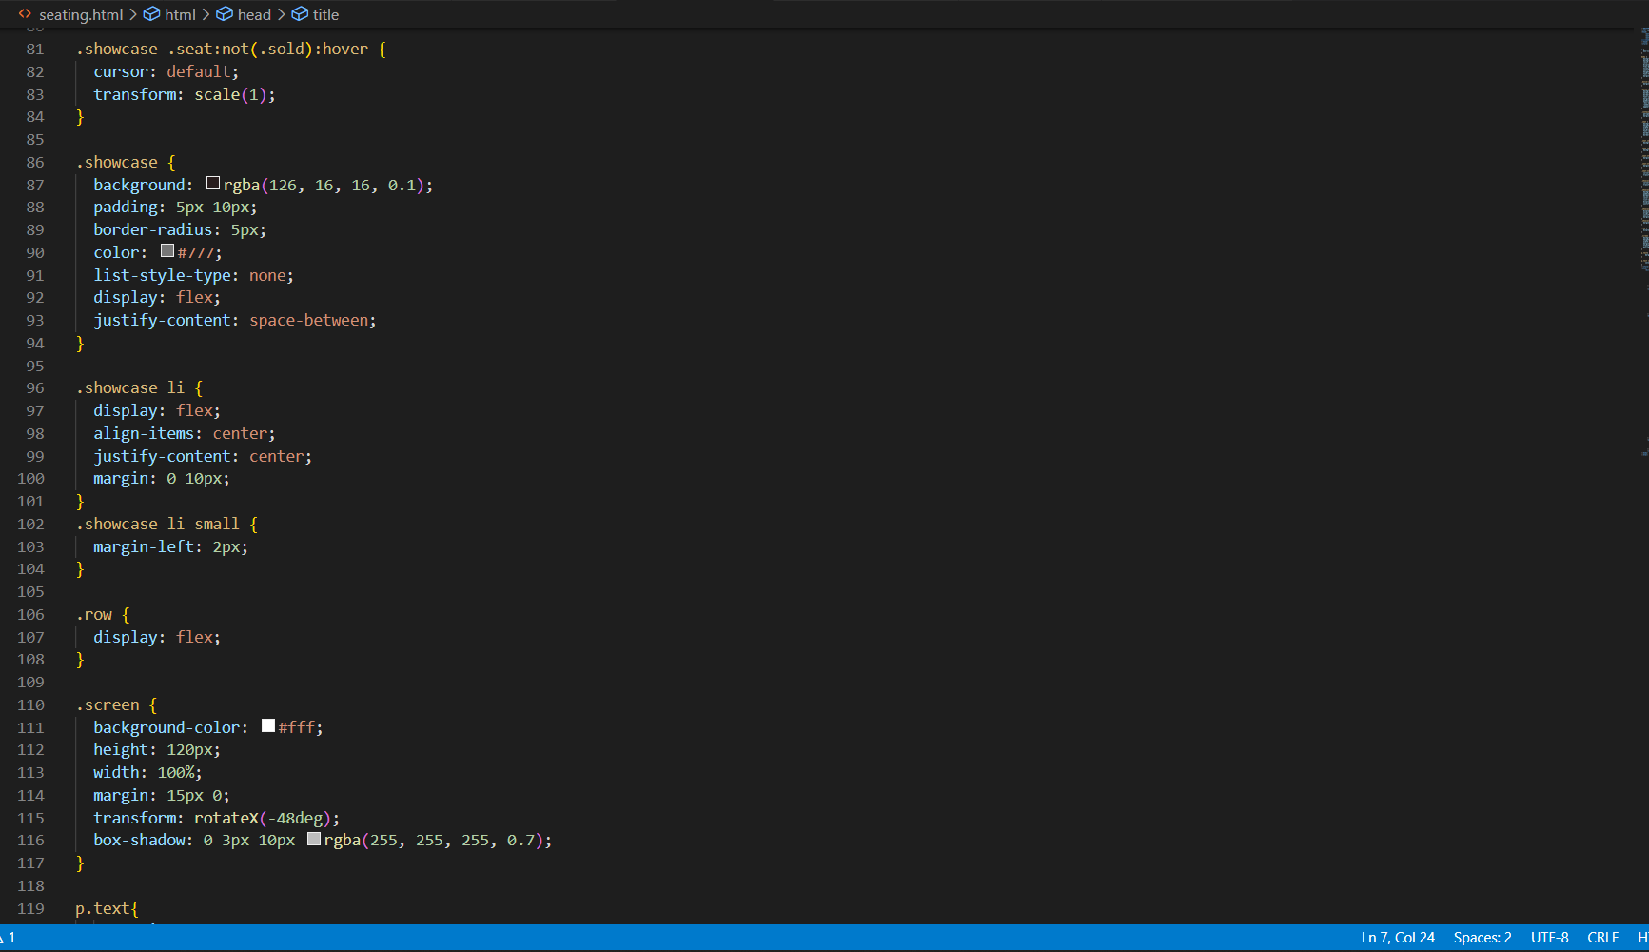

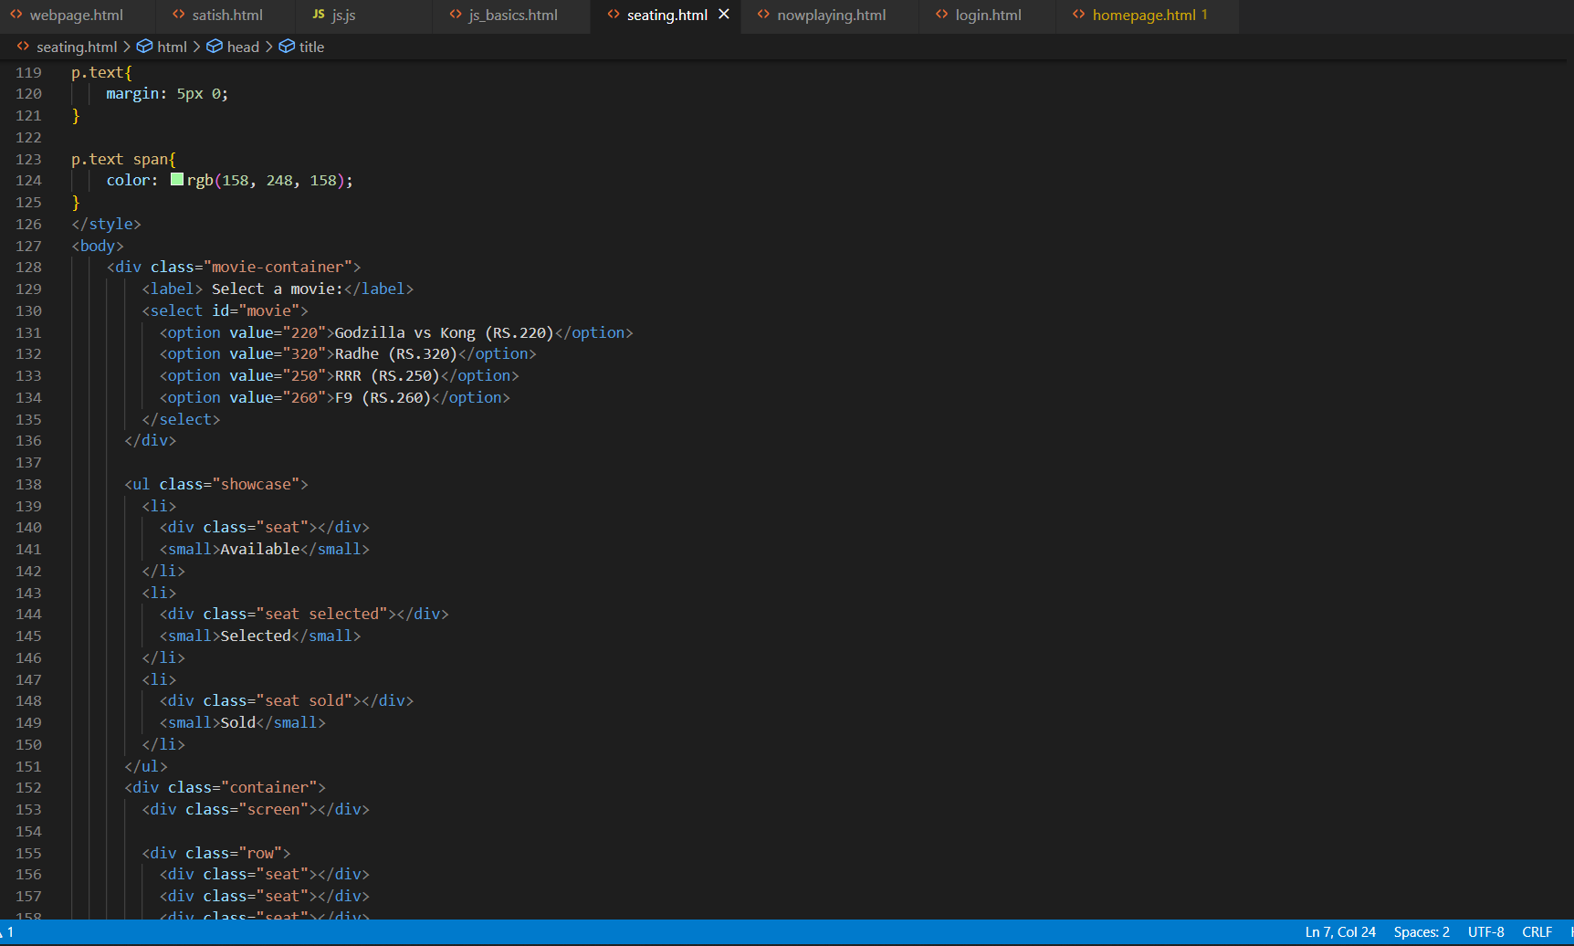

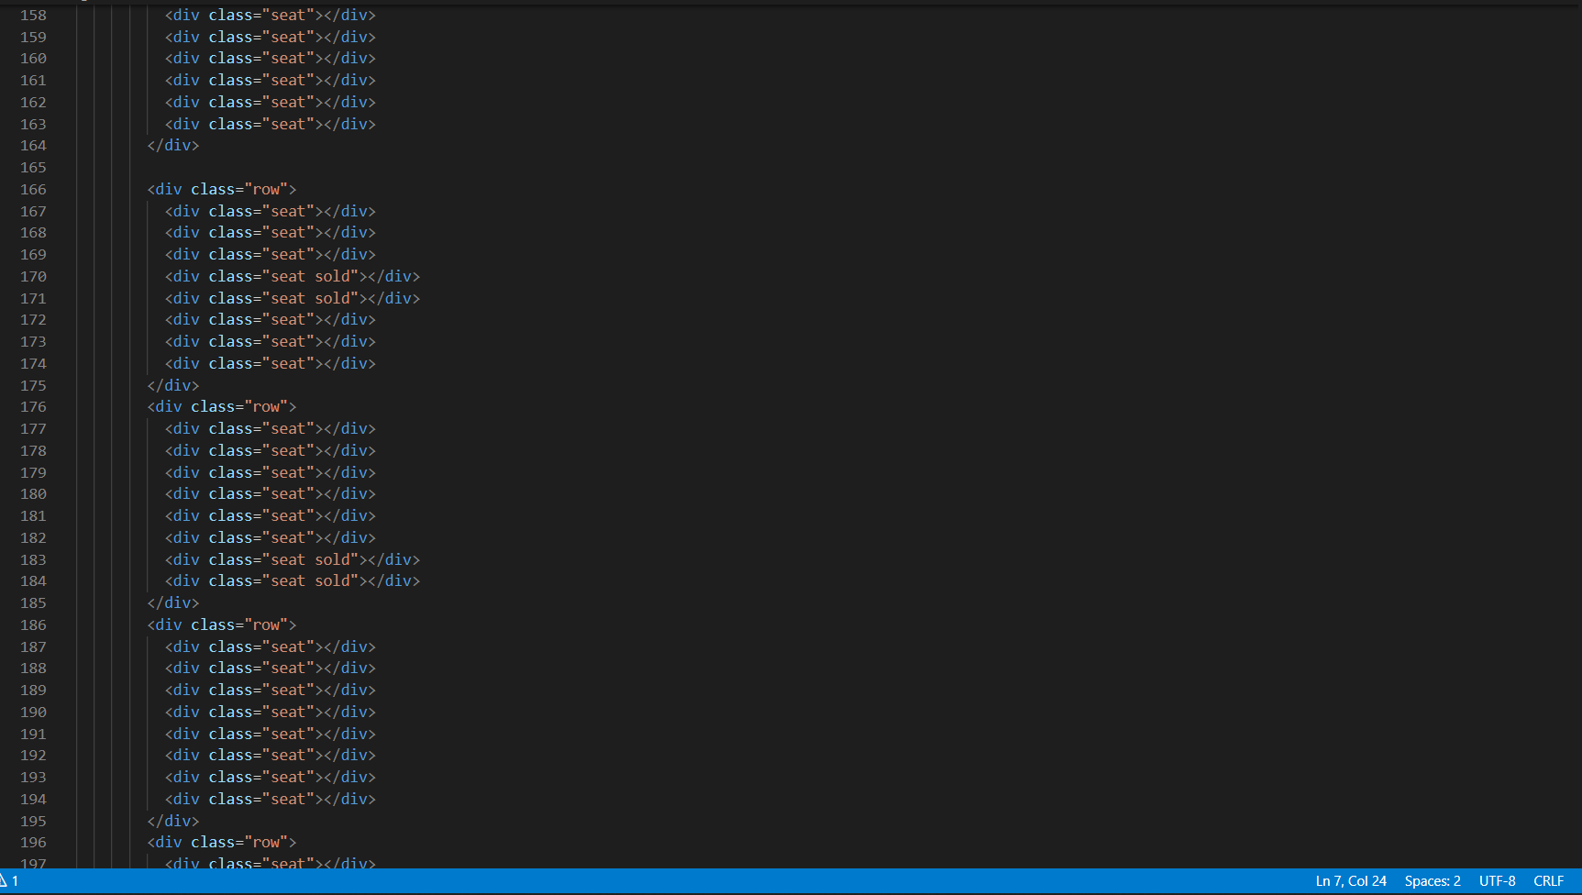

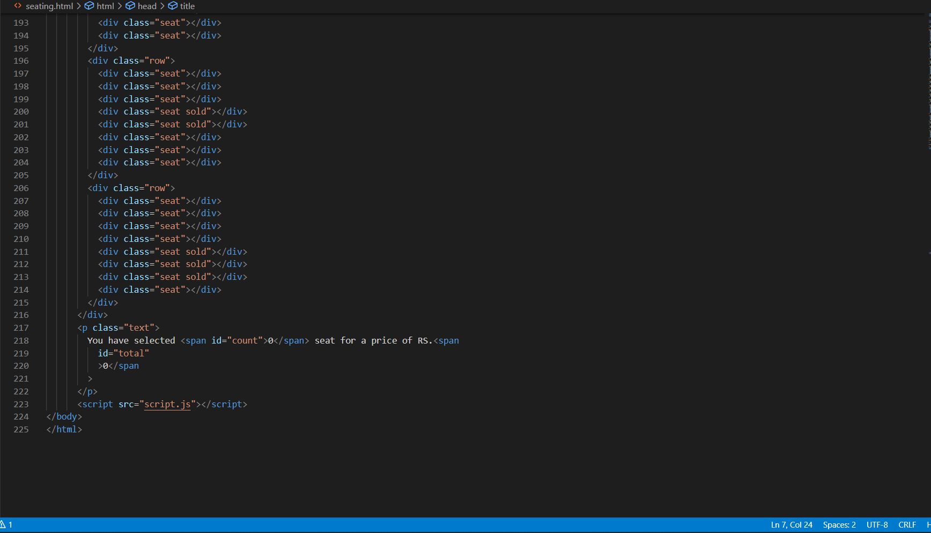

Conclusion: -

The “MOVIE TICKET BOOKING WEBSITE ” is a project done by our group to Help make online connectivity easier and more comfortable. The various features included in the website make each user use the website in an easier and more

efficient way. The designing part of the website makes the website more attractive to the users. After doing this project we are able to recognize the future requirements and knowledge about HTML coding and CSS. Almost all the required features have been made available

on the website within the stipulated time

# LOGIN PAGE: -

* Linked Facebook and Google login pages
* The login button would directly take to the Home page

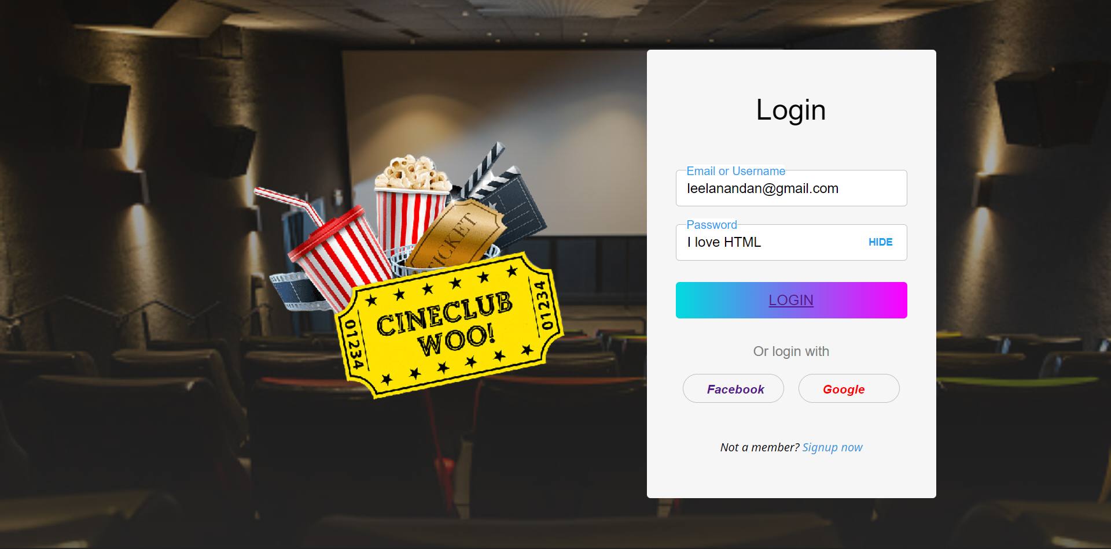

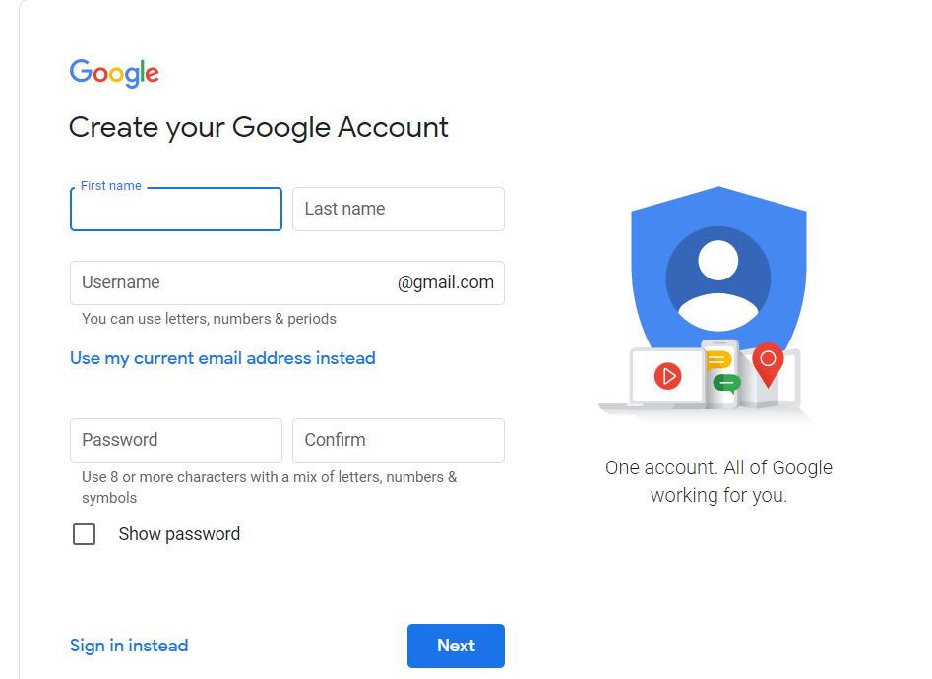

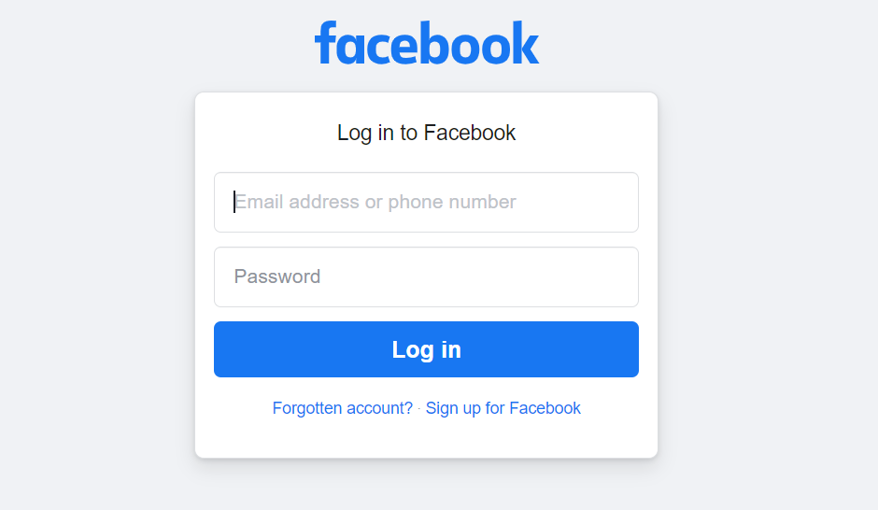

# HOME PAGE:-

* Added a background image
* Log in page button in the nav bar
* On clicking on now playing shows available are visible
* On clicking on Book ticket seating page is opened

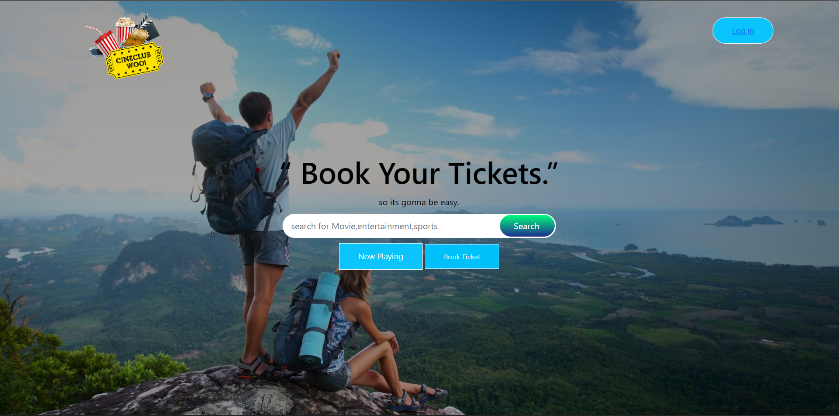

# SLIDER PAGE: -

* Added movie posters from pixel.com
* With the transition time of 0.7 sec, the posters would change
* Added Swiper button

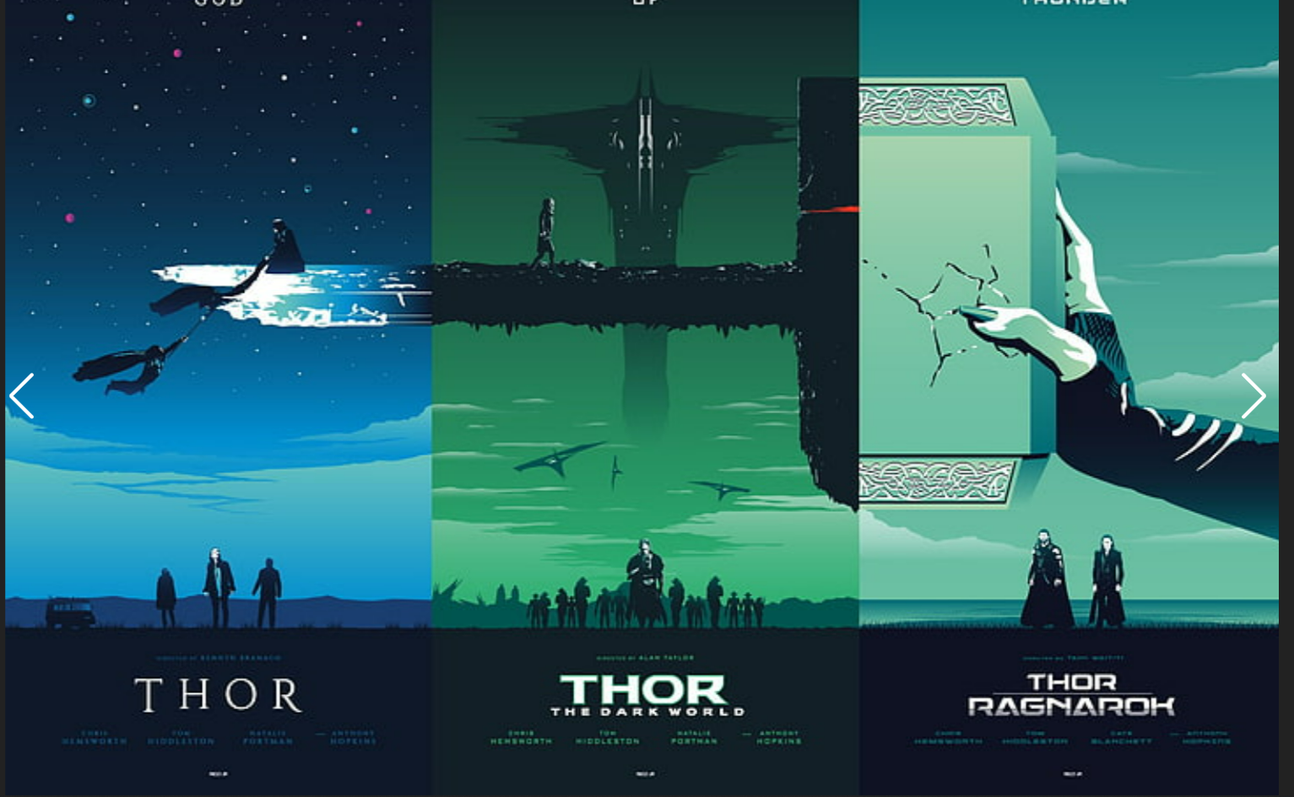

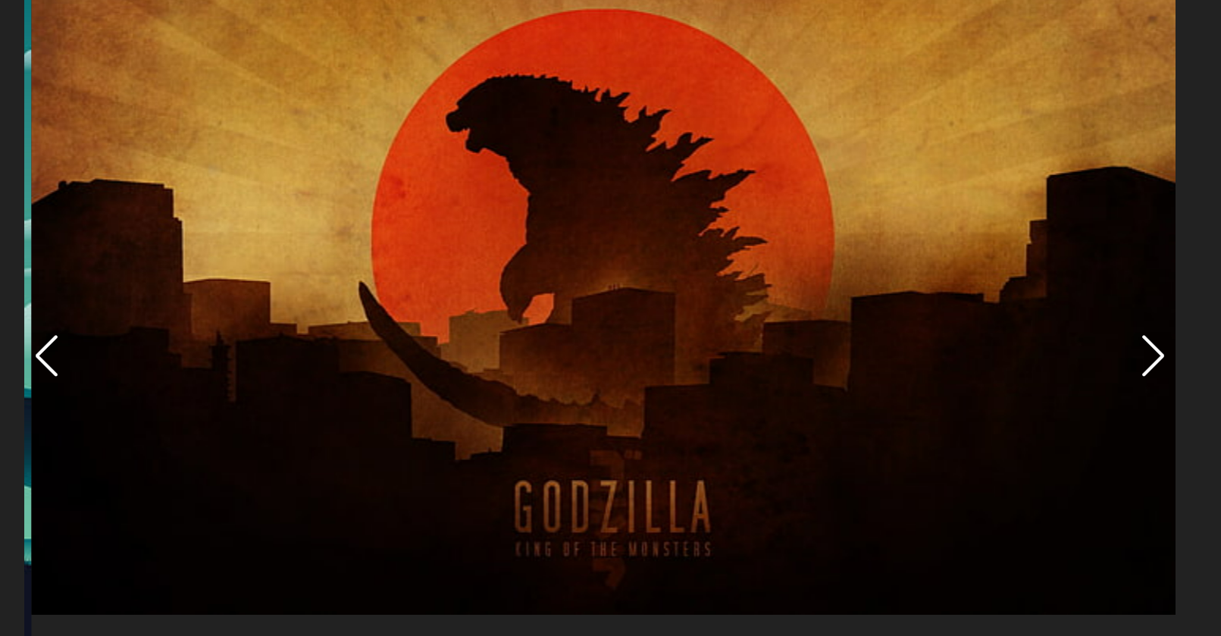

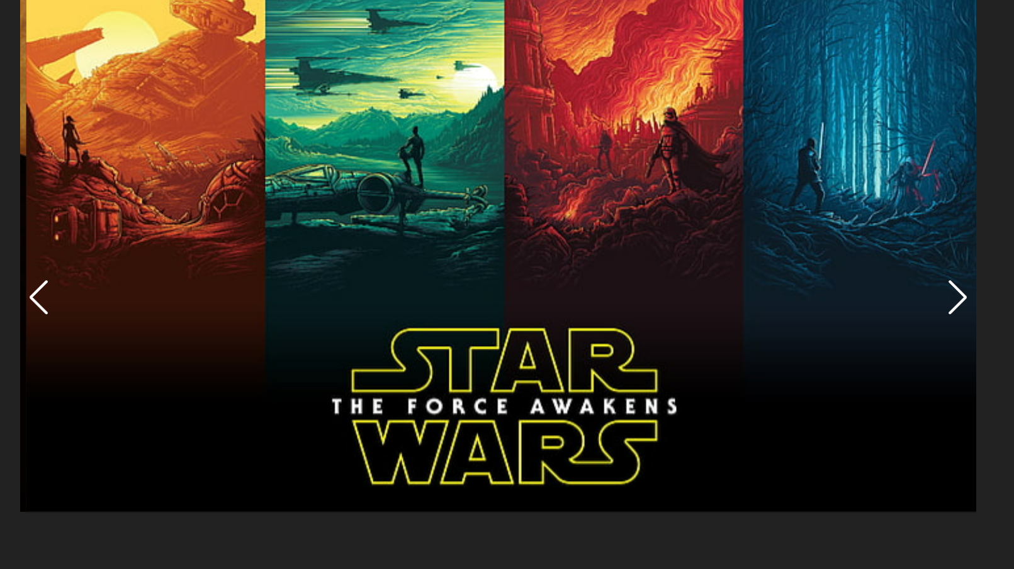

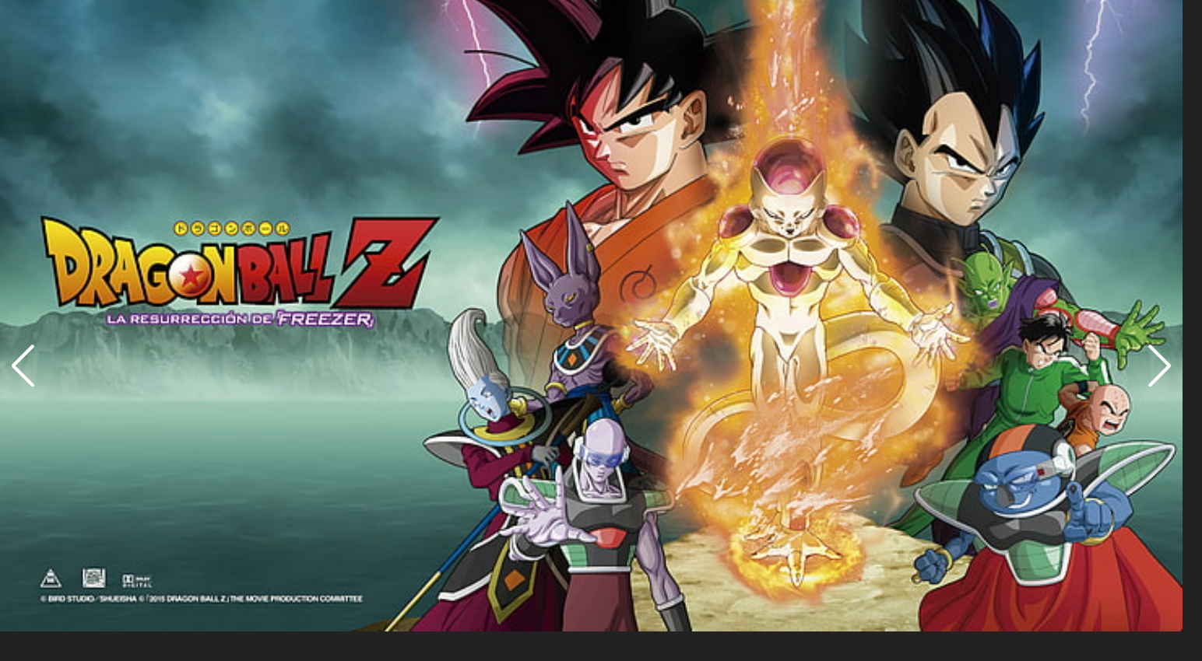

# SEATING PAGE: -

* Used Button tag and added margin and Size to create a view as set shape
* Added Different colors to seats available and reserved



